Titans & MIRAS notes
Neural Memory and Test-Time Training:
Google Research presented 2 new papers during NeurIPS 2025 with an architecture that actively learns and update their own parameters during inference, acting as a "long-term neural memory" rather than a static context window.
Titans: https://arxiv.org/pdf/2501.00663Links to an external site.
MIRAS: https://arxiv.org/pdf/2504.13173Links to an external site.
Big picture:
Image credit - Raphaël MANSUY
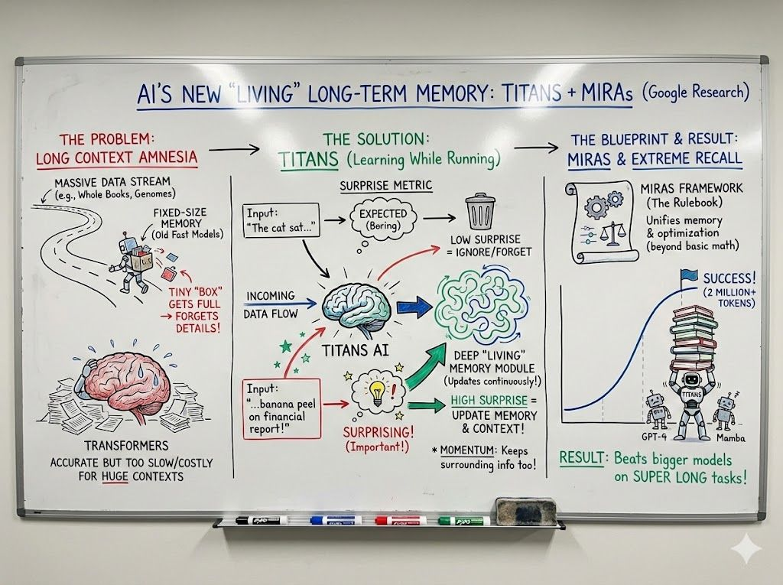
Implementation:
1️⃣ Titans replaces the fixed-state memory of linear RNNs with a deep Multi-Layer Perceptron (MLP) memory module.
2️⃣ The model updates this memory at test-time by calculating a "surprise metric" based on the gradient of the input data.
3️⃣ MIRAS framework generalizes this by treating memory as an optimization problem with customizable loss functions and regularization.
4️⃣ Training is parallelized by chunking sequences, using linear operations within chunks and non-linear updates across chunks.
5️⃣ Models incorporate "Persistent Memory" (fixed learnable weights) alongside the dynamic "Contextual Memory" to store task-specific knowledge.

Insights:
- 💡 Attention mechanisms excellent at short-term memory but fails at efficient long-term storage due to quadratic costs.
- 📈 Deep memory structures (MLPs) significantly outperform vector/matrix-based compression used in Mamba and other linear RNNs.
- 🛠️ Memory updates are effective when driven by "surprise", high gradients indicate unexpected, memorable data.
- 📚 Forgetting mechanisms in recurrent models are mathematically equivalent to retention regularization (weight decay).
- 📉 Standard L2 (Mean Squared Error) objectives make memory sensitive to outliers; L1 or Huber loss provides better stability.
- 🧠 Titans outperforms GPT-4 on "Needle in a Haystack" tasks with 2M+ token contexts despite having fewer parameters.
- ⚡ Deep memory modules exhibit a trade-off where increased depth improves perplexity but slightly reduces training throughput.
Titans and MIRAS show potential to replace, or at least augment, pure Transformer architectures.
Image credit: Philipp Schimd (Google Deepmind)
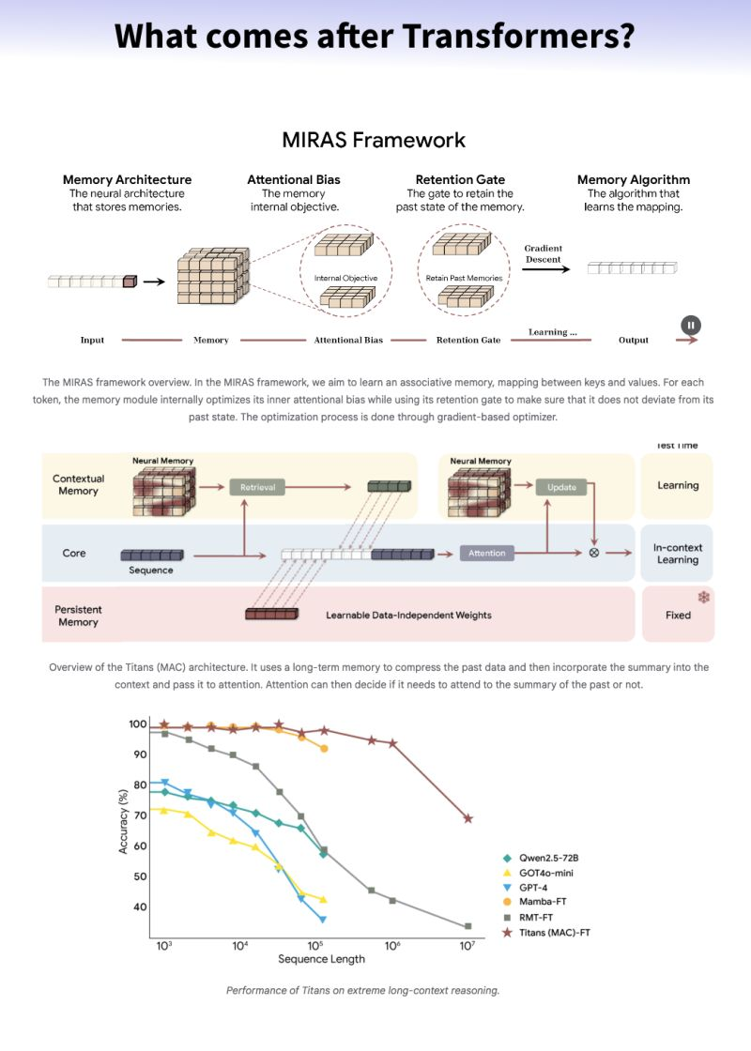
Titans + MIRAS: Helping AI have long-term memory

Titans is a new AI design that can remember important information while it is running, not after retraining. It is much faster than Transformers and can handle very long text.
MIRAS is the theory behind it. It explains how AI models can store, update, and forget memory intelligently.
Key ideas:
- Transformers are accurate but slow with long text
- RNNs are fast but forget too much
- Titans combines both: speed + accuracy
- The model keeps important, surprising information and forgets routine details
Result:
Titans can understand huge documents, adapt in real time, and outperform larger models while using fewer resources.

The introduction of Titans and the MIRAS framework marks a significant advancement in sequence modeling. By employing deep neural networks as memory modules that learn to memorize as data is coming in, these approaches overcome the limitations of fixed-size recurrent states.
Furthermore, MIRAS provides a powerful theoretical unification, revealing the connection between online optimization, associative memory, and architectural design. By moving beyond the standard Euclidean paradigm, this research opens the door to a new generation of sequence models that combine the efficiency of RNNs with the expressive power needed for the era of long-context AI.
The hybrid approach (using attention for the immediate context and Neural Memory for the deep history) suggests the future might be a convergence of RNN efficiency and Transformer performance.

